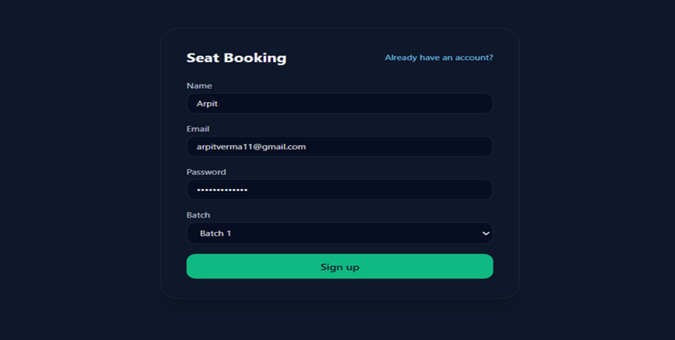
The User Registration interface allows new users to create an account before accessing the seat booking system. This module ensures secure onboarding and batch-based seat allocation.
📌 Features
- Simple and clean signup interface
- Input validation for required user details
- Batch selection for seat grouping
- Secure password handling
- Ready for backend API integration
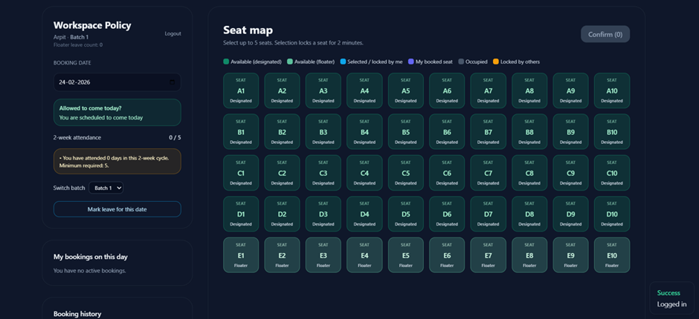
The left panel informs users about their eligibility and booking constraints before they attempt seat reservation.
Key Capabilities
- Displays logged-in user and assigned batch
- Booking date selection
- Attendance tracking within a 2-week cycle
- Eligibility indicator (allowed / restricted)
- Batch switching support
- Leave marking for specific dates
- Daily booking summary
Policy Enforcement
- Users must satisfy minimum attendance requirements
- Booking may be restricted if eligibility conditions fail
- Batch selection influences accessible seats
- Floaters are dynamically assigned

🗺 Seat Map Interface
The seat grid provides a structured layout of available workspace seats and their current status.
Seat Categories
Status | Description
Available (Designated) | Seat assigned to a specific batch but currently free
Available (Floater) | Shared seat that can be booked by any eligible user
Selected / Locked by Me | Temporarily reserved for current user before confirmation
My Booked Seat | Successfully booked seat for the selected date
Occupied | Permanently unavailable or already booked
Locked by Others | Temporarily reserved by another user

⏱ Temporary Seat Locking
To prevent race conditions and double booking:
- Seat selection triggers a temporary lock
- Lock duration: 2 minutes
- Locked seats become unavailable to other users
- Lock expires automatically if booking is not confirmed
This ensures fair concurrent booking behavior.

